 |  | September 2022
Important Dates:  Friday 9/2:  September 2022  10:30am- Music in the Park (S/U)  Monday 9/5:  2pm- Labor Day Party (Game Room)  Wednesday 9/7:  9am- Walmart Run (S/U)  11am- Lunch Outing (S/U)  1-4pm- Fall Scene Investigation with Legacy  Friday 9/9:  10:30am- Music in the Park (S/U)  Wednesday 9/14:  9am- Walmart Run (S/U)  11am- Pedicure Outing (S/U)  Friday 9/16:  10:30am- Music in the Park (S/U)  Tuesday 9/20:  3pm- Apartment Meeting (TH)  Wednesday 9/21:  9am- Walmart Run (S/U)  11am- Lunch Outing (S/U)  11:30am- Ladies of Auxiliary (TH)  3pm- RCF Meeting (Game Room)  Friday 9/23:  10:30am- Music in the Park (S/U)  Monday 9/26:  10am- B&B Movie Theater Outing (S/U)  Wednesday 9/28:  9am- Walmart Run (S/U)  11am- Bowling Outing (S/U)  Friday 9/30:  10:30am- Music in the Park (S/U)  1-3pm- Annual Carnival (TH) | September Birthdays  In astrology, those born from September 1–22 are Virgo’s virgins. Often symbolized by the goddess of agriculture, Virgos are deeply connected to the material world. They are logical, practical, and aware of every detail. Those born from September 23–30 balance the scales of Libra. Libras strive for equilibrium  and symmetry and flourish in harmonious partnerships. Libras often surround themselves with tasteful art objects and designs that  create balanced environments.  RESIDENTS:  Sara S. 9/1; Pat A. 9/3; Don H. 9/4; Dorothy M. 9/5; Terry M. 9/10; Lee E. 9/11; Letha C. 9/11; Cordie K. 9/12; Geri B. 9/14; Faye A. 9/18; Verna G. 9/22; Jean H. 9/26.  EMPLOYEES:  John H. 9/6; Heather P. 9/8; Nicole L. 9/10; Rose K. 9/19; Diann L. 9/26; Janet L. 9/27; Mary J. 9/28.  VOLUNTEERS:  Dee Ann W. 9/26.  By Any Other Name  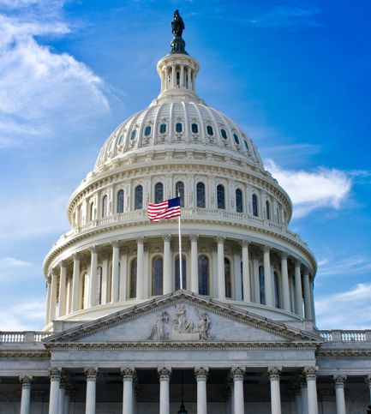  In January of 1791, George Washington, using the power vested to him by Congress through 1790’s Residence Act, chose a site along the Potomac River for the new U.S. capital. Washington appointed three commissioners with the task of naming this new city, all the while assuring them that “they should decide freely on their own view of things.” Rumors swirled in Philadelphia of the city being named Washingtonople or Washingtonopolis. Others lobbied that it be called Columbus, in honor  of Christopher Columbus and the impending 300th anniversary of his arrival in America. Finally, on September 8, 1791, the three commissioners were joined by Thomas Jefferson and James Madison to decide on the name once and for all. A compromise was struck.  The city itself would be called simply Washington, with the surrounding area known as the District of Columbia. |  | Our Lady of Mercy
 |  |  | Care with Dignity | 2115 Maturana Drive Liberty, MO 64068 | 816-781-5711
Celebrating September

Classical Music Month

Piano Month

Hispanic Heritage Month
September 15–October 15

World Letter Writing Day
September 1

Labor Day (U.S.)
September 5

Grandparents’ Day
September 11

International Day of Democracy
September 15

International Talk Like a Pirate Day
September 19

World Alzheimer’s Day
September 21

Rosh Hashanah Begins
September 25

Fall Foliage Week
September 25–October 1

Ancestor Appreciation Day
September 27

Sunken Treasure

On September 1, 2013, undersea explorer Barry Clifford was making yet another dive to the sunken Whydah, the only fully authenticated Golden Age pirate shipwreck in American waters. Clifford discovered the ship and its
trove of pirate-era artifacts in 1984, but he had yet to find the 400,000 gold pieces that purportedly sank with the
ship off the coast of Cape Cod in 1717 during a violent nor’easter. On that September day, Clifford and his team discovered several coin-shaped masses chemically crusted together after centuries underwater. The report
of the Whydah and its vast trove of pirate artifacts gave other treasure-seekers hope that similar sunken wrecks still wait to be found.

There is no shortage of rumors when it comes to pirate shipwrecks and lost hordes of gold. Captain Kidd, before being executed for piracy, attempted to save himself by claiming that he had buried a treasure worth 400,000 British pounds. In 1700, ten thousand pounds of treasure were found buried in the sands of Gardiner Island off the coast of Long Island, New York. In 2015, Barry Clifford discovered a 50-kilogram silver bar off the coast of Madagascar that he believed was part of Kidd’s lost treasure. Despite authorities confirming the bar was
95% lead and was not evidence of Kidd’s lost treasure,
the find only heightened the frenzy to find Kidd’s lost loot.

Edward Teach, better known as Blackbeard, was notorious for plundering ships laden with gold and silver. Blackbeard’s ledgers indicate that he had amassed a pirate fortune worth millions. Before his death, he declared that his
“real” treasure “lay in a location only known to him
and the devil.” When Blackbeard’s ship Queen Anne’s Revenge was discovered in waters near Beaufort,
North Carolina, in 1996, treasure hunters believed that
the treasure was finally found. Underwater archaeologists uncovered loaded cannons, a blunderbuss barrel,
anchors, and other artifacts, but no trove of gold. Like
so many times before, the absence of treasure did
not dim the hopes of treasure seekers but stoked the passions of exploration and discovery.

Race to the Finish  Each Labor Day, 20,000 visitors swarm the ranch  of Dan and Peggy Eoff in Clinton, Arkansas, for the annual National Championship Chuckwagon Races. The idea started off simple enough in 1986. Dan and Peggy wanted to throw a party over Labor Day weekend. To make it interesting, Dan suggested racing chuckwagons. Eight drivers took part in that first chuckwagon race. Today, 150 teams compete in five divisions to take  home the title of national champion.  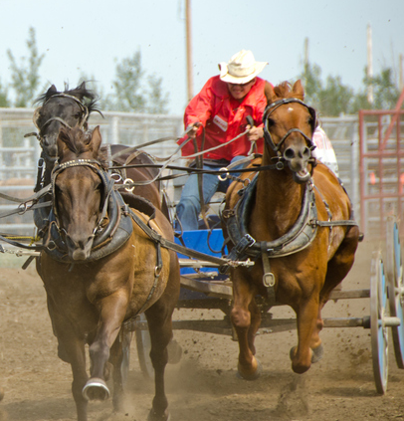  The race has few rules, but following those rules is often the key to victory. Each team consists  of three people: a driver, a cook, and an outrider who rides a horse alongside the chuckwagon. At  the start of the race, the cook and outrider stand outside the chuckwagon on the ground. At the judge’s signal, the cook loads the stove into the wagon and climbs aboard. When the starting pistol is fired, the outrider loads a tent into the wagon, climbs into the saddle, and must race  the chuckwagon to the finish line. The outrider must pass the finish line before the chuckwagon, and the chuckwagon must pass the finish line  with the cook, driver, tent, and stove intact. With four teams, several animals, and 20,000 roaring fans, the race is far from easy.  The chuckwagon was invented by a Texas rancher named Charles Goodnight around 1866. Faced with the prospect of driving 2,000 longhorn cattle from Texas to Colorado, Goodnight proposed retrofitting an Army surplus wagon with cabinets, shelves, drawers, a durable worktop, a barrel for holding water, and plenty of space for storing cowboys’ bedrolls and blankets. Since cowboys called their meals chuck, it made perfect sense  to call this wagon the chuckwagon.  Of course, chuckwagons weren’t made for racing. Old cowboy legends tell of how, at the end of a cattle drive, cowboys would race into town to spend their pay, and the last one in had to buy drinks for all. Cooks would race in on their chuckwagons. Chuckwagon racing as a spectator sport originated at the 1923 Calgary’s Stampede.  September 2022 | Your Library  Featuring this month: Danielle Still and Nicholas Sparks! Both are romantic and mystery authors with multiple award-winning novels. Come check out your Library as new novels come in every month!  If you have any questions or concerns about your library, please contact Don B.  Book Club  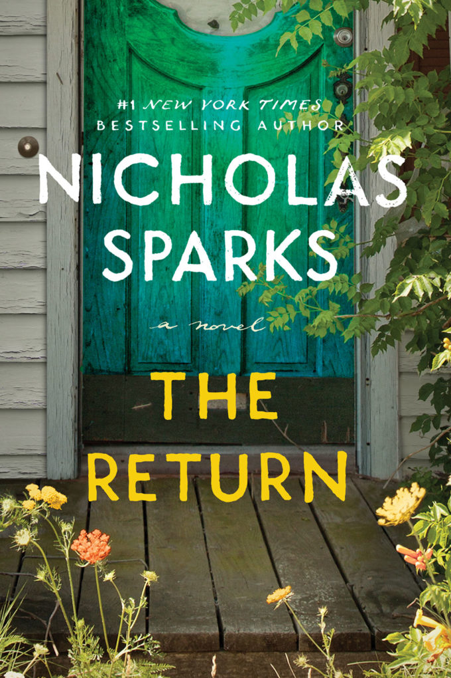  The feature for the month of September is The Return by Nicholas Sparks.  This novel is a #1 New York Times Bestseller, about an injured Army doctor and the two women whose secrets will change the course of his life.  Limited books are available, please contact the Activity Department to join our Book Club! Extension: 5002 |  | Dancing Through History  Waltzes. Foxtrots. Tangos. Quicksteps. Rhumbas and mambos. Ballroom dancing takes many forms, which should make  it easy to find a style that suits your tastes during Ballroom Dancing Week from September 16–25.  Just as the Renaissance brought many important milestones in the fields of art and science, so too did the era leave its mark on dancing. Dance had long been separated into two different forms or styles. One type of dance was practiced openly and in public, while another type was practiced by the aristocracy and royalty behind closed doors during special occasions. This type of formal dancing was first recorded in 1588 by  the French cleric Jehan Tabourot, writing under the pen name Thoinot-Arbeau.  Most of what we know of the origins of  ballroom dancing comes from Thoinot-Arbeau’s Orchesographie, a study of the social dances  of the French aristocracy. The book presents  a description of the popular dances of the day, information on how one should behave in the ballrooms of the rich and powerful, and the interactions between dancers and musicians. Shakespeare depicted many of these dances  in his stage plays, which popularized them beyond the private manors of France.  Two dances helped propel ballroom dancing into  a worldwide phenomenon. In 1650, the French King Louis XIV took up dancing the minuet. For the next 200 years, the minuet would spread to ballrooms in every corner of France and solidify ballroom dance as a social practice. As the minuet faded, the waltz took hold. At first, many balked at the scandalous way partners dancing the waltz held each other close. Soon, however, everyone was waltzing. Those craving new dances invented the polka, mazurka, and schottische. To accommodate the dance craze, new ballrooms were built in cities and hotels. Dancing was no longer just for the rich but a pursuit for anyone willing to give it a try.  September 2022 | A Hairy Situation  Men, put away your razors. September 3 is World Beard Day. According to the bearded founders of Beard Day, it is traditional on  this holiday for the beardless to wait on the bearded hand and foot. Perhaps that is why  so few of the beardless care to know that September 3 is World Beard Day.  Why do men grow beards? Scientists have attempted to answer this question for a long time. A common theory is that men groom their facial hair to attract a mate. Studies show, however, that most women don’t like beards. Instead, beards are just another way that men compete with each other. Men with beards are often perceived as older, stronger, and more aggressive than other men. In this light, beards are a show of dominance. Other studies have shown that in times when there are more single men competing for fewer women, mustaches and beards become fashionable. Does that explain the current beard trend? One social scientist believes that beards are in fashion due to a “crisis of masculinity” and that men who feel disassociated from their masculinity grow big beards to reassure themselves.  Dining In  Something transformative happened on September 10, 1953. Swanson introduced the TV dinner, and it was an instant success. Swanson was a nationally known food brand famous for its poultry. After an abysmal Thanksgiving in 1952, Swanson found itself with 260 tons of leftover turkey. Swanson salesman Gerry Thomas sketched the idea of a three-sectioned tray, one that could act as both  a cooking and serving tray. Savvy Swanson advertisers linked the new frozen food trays with the exciting new appliance of the era,  the television, naming it the “TV dinner” and even designing the packaging to look like a tv. Swanson sold 10 million units in its first year, and cooking was transformed forever.

