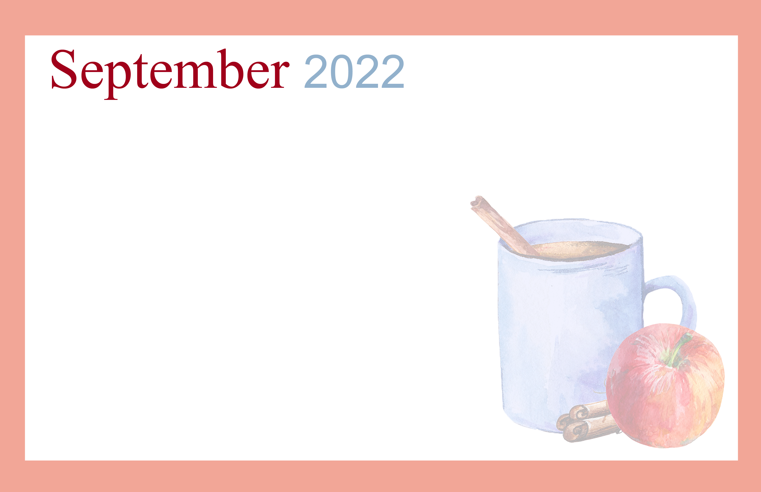  ACTIVITIES |  |  |  | 9am- One on Ones  9am- Standing Exercise (GR)  9:30am- Sewing Club (CR)  10am- Memory Games (3RCF)  10:15am- Mass (C)  11am- Nail Salon (AR)  12pm- Newsletter Highlight (DH)  1-3pm- Country Store  1pm- Exercise (GR)  2pm- Paint by Numbers (AR)  3pm- Yahtzee (AR)  6:30pm- Genealogy (L) | 9am- One on Ones  10am- Current Events (AR)  10:15am- Mass (C)  10:30am- Music in the Park (S/U)  11am- Exercise (GR)  1-3pm- Country Store  1pm- Skeleton Leaves Craft (AR)  2pm- Scriptures &Reflections (C)  2pm- One on Ones  3pm- Social Hour (GR) | 9am- Walking Group (CY)  10am- Puzzles (2RCF)  11am- Paint by Numbers (AR)  1:30pm- Movie w/ Kathy (GR)  6:30pm- Quarter Bingo w/ Mary (GR)
9am- Bethany Church (TH)  10:30am- Rosary (C)  11am- Mass (C) | 9am- One on Ones  10am- Puzzles (2RCF)  10:15am- Mass (C)  11am- Drum Exercise (GR)  1-3pm- Country Store  2pm- Labor Day Party (GR) | 9am- One on Ones  10am- Memory Games (2RCF)  10:15am- Mass (C)  11am- Nail Salon (AR)  1-3pm- Country Store  1pm- Exercise (GR)  2pm- Protestant Service (C)  2pm- Story Time (AR)  3pm- Paint by Numbers (AR) | 9am- Walmart Run (S/U)  9am- One on Ones  10am- Puzzles (3RCF)  10:15am- Mass (C)  11am- Trivia (AR)  11am- Lunch Outing (S/U)  1-3pm- Country Store  1-4pm- Fall Scene Investigation w/ Legacy (GR)  1pm- Brain Fitness (GR)  2pm- Pool  3pm- Book Club (L) | 9am- One on Ones  9am- Standing Exercise (GR)  9:30am- Sewing Club (CR)  10am- Memory Games (3RCF)  10:15am- Mass (C)  11am- Nail Salon (AR)  1-3pm- Country Store  1pm- Exercise (GR)  2pm- Sing-Along w/ Ina (GR)  3pm- Yahtzee (AR)  6:30pm- Genealogy (L) | 9am- One on Ones  10am- Current Events (AR)  10:15am- Mass (C)  10:30am- Music in the Park (S/U)  11am- Exercise (GR)  1-3pm- Country Store  1pm- Fall Door Décor (AR)  2pm- Scriptures &Reflections (C)  2pm- One on Ones  3pm- Social Hour (GR) | 9am- Walking Group (CY)  10am- Puzzles (2RCF)  11am- Paint by Numbers (AR)  1:30pm- Movie w/ Kathy (GR)  6:30pm- Quarter Bingo w/ Mary (GR)  7pm- Square Dancing (TH)
9am- Bethany Church (TH)  10:30am- Rosary (C)  11am- Mass (C)  12pm- Grandparent’s Day Lunch (DH)  3:25pm- Chiefs V. Cardinals  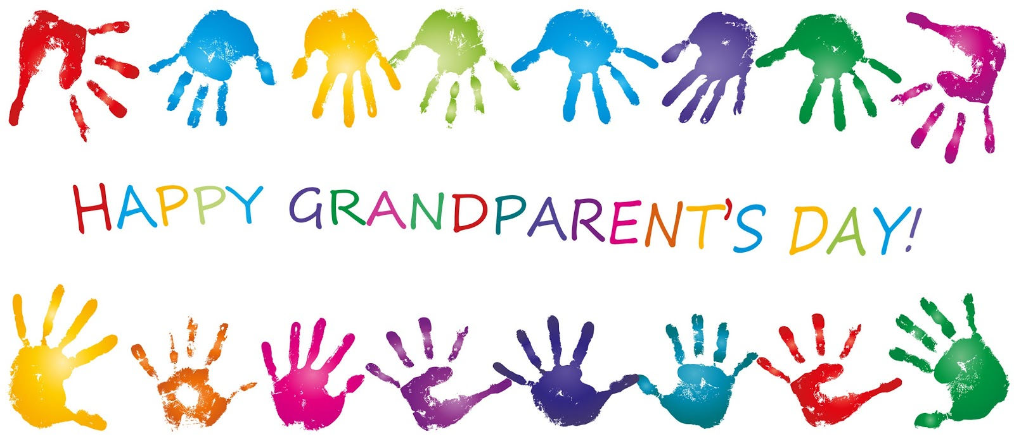 | 9am- One on Ones  10am- Puzzles (2RCF)  10am- Library Outing (S/U)  10:15am- Mass (C)  11am- Drum Exercise (GR)  1-3pm- Country Store  1pm- Money Bingo (GR)  2pm- Dominos (AR)  3pm- Snack Cart  4pm- One on Ones | 9am- One on Ones  10am- Memory Games (2RCF)  10:15am- Mass (C)  11am- Nail Salon (AR)  1-3pm- Country Store  1pm- Exercise (GR)  2pm- Protestant Service (C)  2pm- Story Time (AR)  3pm- Paint by Numbers (AR) | 9am- Walmart Run (S/U)  9am- One on Ones  10am- Puzzles (3RCF)  10:15am- Mass (C)  11am- Trivia (AR)  11am- Pedicure Outing (S/U)  1-3pm- Country Store  1pm- Brain Fitness (GR)  1pm- Money Bingo (GR)  2pm- Putt Golf (GR)  3pm- Smores (GR) | 9am- One on Ones  9am- Standing Exercise (GR)  9:30am- Sewing Club (CR)  10am- Memory Games (3RCF)  10:15am- Mass (C)  11am- Nail Salon (AR)  1-3pm- Country Store  1pm- Exercise (GR)  2pm- Paint by Numbers (AR)  3pm- Yahtzee (AR)  6:30pm- Genealogy (L)  7:15pm- Chiefs V. Chargers | 9am- One on Ones  10am- Current Events (AR)  10:15am- Mass (C)  10:30am- Music in the Park (S/U)  11am- Exercise (GR)  1-3pm- Country Store  1pm- Leaf Rubbing Craft (AR)  2pm- Scriptures &Reflections (C)  2pm- One on Ones  3pm- Social Hour (GR) | 9am- Walking Group (CY)  10am- Puzzles (2RCF)  11am- Paint by Numbers (AR)  1:30pm- Movie w/ Kathy (GR)  6:30pm- Quarter Bingo w/ Mary (GR)  
9am- Bethany Church (TH)  10:30am- Rosary (C)  11am- Mass (C) | 9am- One on Ones  10am- Puzzles (2RCF)  10:15am- Mass (C)  11am- Drum Exercise (GR)  1-3pm- Country Store  1pm- Money Bingo (GR)  2pm- Dominos (AR)  3pm- Snack Cart  4pm- One on Ones | 9am- One on Ones  10am- Memory Games (2RCF)  10:15am- Mass (C)  11am- Nail Salon (AR)  1-3pm- Country Store  1pm- Exercise (GR)  2pm- Protestant Service (C)  2pm- Story Time (AR)  3pm- Paint by Numbers (AR)  3pm- Apartment Meeting (TH) | 9am- Walmart Run (S/U)  9am- One on Ones  10am- Puzzles (3RCF)  10:15am- Mass (C)  11am- Trivia (AR)  11am- Lunch Outing (S/U)  11:30am- Ladies of Auxiliary (TH)  1-3pm- Country Store  1pm- Brain Fitness (GR)  1pm- Money Bingo (GR)  2pm- Pool (GR)  3pm- Book Club (L)  3pm- RCF Meeting (GR) | 9am- One on Ones  9am- Standing Exercise (GR)  9:30am- Sewing Club (CR)  10am- Memory Games (3RCF)  10:15am- Mass (C)  11am- Nail Salon (AR)  1-3pm- Country Store  1pm- Exercise (GR)  2pm- Sing-Along w/ Ina (GR)  3pm- Yahtzee (AR)  6:30pm- Genealogy (L) | 9am- One on Ones  10am- Current Events (AR)  10:15am- Mass (C)  10:30am- Music in the Park (S/U)  11am- Exercise (GR)  1-3pm- Country Store  1pm- Apple Stamping (AR)  2pm- Scriptures &Reflections (C)  2pm- One on Ones  3pm- Social Hour (GR)  6pm- Slightly Off Broadway (S/U) | 9am- Walking Group (CY)  10am- Puzzles (2RCF)  11am- Paint by Numbers (AR)  1:30pm- Movie w/ Kathy (GR)  6:30pm- Quarter Bingo w/ Mary (GR)
9am- Bethany Church (TH)  10:30am- Rosary (C)  11am- Mass (C)  12pm- Chiefs V. Colts  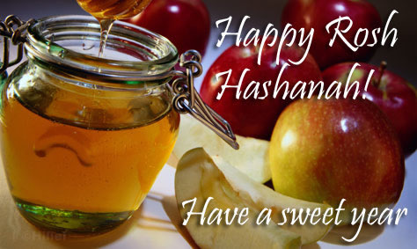 | 9am- One on Ones  10am- Puzzles (2RCF)  10am- B&B Outing (S/U)  10:15am- Mass (C)  11am- Drum Exercise (GR)  1-3pm- Country Store  1pm- Money Bingo (GR)  2pm- Dominos (AR)  3pm- Snack Cart  4pm- One on Ones | 9am- One on Ones  10am- Memory Games (2RCF)  10:15am- Mass (C)  11am- Nail Salon (AR)  1-3pm- Country Store  1pm- Exercise (GR)  2pm- Protestant Service (C)  2pm- Story Time (AR)  3pm- Paint by Numbers (AR) | 9am- Walmart Run (S/U)  9am- One on Ones  10am- Puzzles (3RCF)  10:15am- Mass (C)  11am- Trivia (AR)  11am- Bowling Outing (S/U)  1-3pm- Country Store  1pm- Brain Fitness (GR)  1pm- Money Bingo (GR)  2pm- Putt Golf (GR)  3pm- Smores (GR) | 9am- One on Ones  9am- Standing Exercise (GR)  9:30am- Sewing Club (CR)  10am- Memory Games (3RCF)  10:15am- Mass (C)  11am- Nail Salon (AR)  1-3pm- Country Store  1pm- Exercise (GR)  2pm- Paint by Numbers (AR)  3pm- Yahtzee (AR)  6:30pm- Genealogy (L) | 9am- One on Ones  10am- Current Events (AR)  10:15am- Mass (C)  10:30am- Music in the Park (S/U)  11am- Exercise (GR)  1-3pm- Country Store  1-3pm- Annual Carnival (TH)  2pm- Scriptures &Reflections (C)
Our Lady of Mercy Country Home | Care with Dignity | 2115 Maturana Drive Liberty, MO 64068 | 816-781-5711
Sunday | Monday | Tuesday | Wednesday | Thursday | Friday | Saturday
 |  |  |  | 1 | 2 | 3
4 | 5  Labor Day | 6 | 7 | 8 | 9 | 10
11  Grandparents Day | 12 | 13 | 14 | 15 | 16 | 17  Oktoberfest Begins
18 | 19 | 20 | 21 | 22  Autumn Begins | 23 | 24
25  Rosh Hashanah Begins | 26 | 27 | 28 | 29 | 30

