 |  | December 2022
Important Dates to Remember:  Saturday 12/3rd:  December 2022  1:30pm- Movie w/ Kathy (Game Room)  Tuesday 12/6th:  3pm- Music Therapy (Game Room)  6:30pm- Card Games (Library)  Wednesday 12/7th:  9am- Walmart Run (Sign Up)  5:30pm- Pinochle (Library)  Thursday 12/8th:  2pm- Pitch w/ Betty (Game Room)  6:30pm- Genealogy (Library)  Saturday 12/10th:  1:30pm- Movie w/ Kathy (Game Room)  Tuesday 12/13th:  6:30pm- Card Games (Library)  Wednesday 12/14th:  9am- Walmart Run (Sign Up)  3pm- Book Club (Library)  5:30pm- Pinochle (Library)  Thursday 12/15th:  2pm- Pitch w/ Betty (Game Room)  6:30pm- Genealogy (Library)  Saturday 12/17th:  1:30pm- Movie w/ Kathy (Game Room)  Tuesday 12/20th:  3pm- Apartment Meeting (Tighe Hall)  6:30pm- Card Games (Library)  Wednesday 12/21st:  9am- Walmart Run (Sign Up)  3pm- RCF Meeting (Game Room)  5:30pm- Pinochle (Library)  Thrursday 12/22nd:  1:30pm- Resident Christmas Party (Tighe Hall)  6:30pm- Genealogy (Library)  Saturday 12/24th:  Christmas Eve | December Birthdays  In astrology, those born from December 1–21 are Archers of Sagittarius. These Archers are philosophical seekers of knowledge who love traveling to new places to absorb new cultures. Those born from December 22–31 are Capricorn’s Goats. Patience, perseverance, and dedication help Goats climb to the highest  of heights. Their drive to the top makes them excellent partners and collaborators.  Residents:  Ina U. 12/14th  Jane H. 12/14th  Catherine V. 12/15th  Rheta M. 12/15th  Kay T. 12/16th  Sunday 12/25th:  Merry Christmas!!!  Tuesday 12/27th:  3pm- Music Therapy (Game Room)  6:30pm- Card Games (Library)  Wednesday 12/28th:  9am- Walmart Run (Sign Up)  3pm- Book Club (Library)  Thursday 12/29th:  2pm- Pitch w/ Betty (Game Room)  6:30pm- Genealogy (Library)  Friday 12/30th:  1:30pm- New Year’s Eve Party (Tighe Hall)  Saturday 12/31st:  1:30pm- Movie w/ Kathy (Game Room)  Happy New Year’s Eve!!! |  | Our Lady of Mercy
 |  |  | Care with Dignity | 2115 Maturana Drive Liberty, MO 64068 |816-781-5711
Celebrating December

Safe Toys and Gifts Month

Spiritual Literacy Month

Write a Friend Month

Cookie Cutter Week
December 1–7

Coats and Toys for
Kids Day
December 3

St. Nicholas Day
December 6

Nobel Prize Day
December 10

Las Posadas
December 16–24

Hanukkah
December 18–26

Yaldā
December 21

Christmas
December 25

New Year’s Eve
December 31

A Fresh Take on Peppermint

Peppermint bark. Peppermint lattes. Peppermint candy canes. There is no doubt about it—peppermint is the undisputed flavor of the winter season. Mint is full of the chemical menthol, which, when tasted, activates the
same nerve sensors that allow us to feel cold. We love
the refreshing, cooling sensation of mint in our mouths
and are reminded of winter each time we take a taste.
But there is more to the story of peppermint’s hold on
the winter season than its chemical composition.

Mint-flavored hard candies have been made for hundreds of years. Before the invention of air-conditioning, hard candy could be made only during the cool, dry months of winter, for heat and humidity would spoil the candy. Mint
is a reliable flavoring because it does not cook off during the manufacturing process. Its flavor remains incredibly strong. For this reason, mint-flavored hard candy has always been a wintertime treat.

Legend has it that the first candy canes were invented
in the 17th century by a German choirmaster who bribed
his choirboys with peppermint candy sticks to keep them complacent during mass. Candy in church was not
exactly solemn, so the choirmaster asked the candy
maker to fashion the candy sticks into shepherds’
crooks, honoring Jesus.

It wasn’t until 1847 that a German Swedish immigrant to America named August Imgard used the candy cane as
a Christmas decoration. He spun white hard candy into
its crooked shape and hung the canes along with paper ornaments from a blue spruce. It would take a few more decades and the advent of mass production techniques for candy canes to get their red stripes. Why red? Some say this color represents the blood shed by Jesus on the cross, while others attribute it to the red berries and green garland of evergreen holly that has been associated with Yule traditions. Don’t wait until December 26, Candy Cane Day, to enjoy candy canes. Most people start buying them the day after Thanksgiving.
Still Living in Infamy  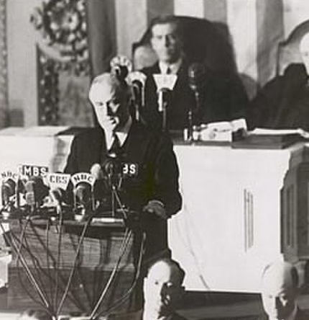  U.S. President Franklin D. Roosevelt called December 7, 1941, “a date which will live  in infamy.” 81 years later, we still remember the attack on Pearl Harbor and pause to honor all who were lost.  Pearl Harbor is a U.S. naval base located near Honolulu, Hawaii. It was home to the bulk of the U.S. Navy’s Pacific Fleet, hundreds of airplanes, and thousands of soldiers. American intelligence officials never expected Japanese forces to start a war with the United States with an attack on Hawaii, 4,000 miles away. For this reason, Pearl Harbor was left largely undefended on December 7, 1941. As a target, Pearl Harbor was too good of an opportunity for the Japanese to ignore.  In an audacious sneak attack, without any declaration of war, Japanese forces began their assault on Pearl Harbor at around 8 a.m. At 8:10,  a 1,800-pound bomb fell through the deck of the battleship USS Arizona and struck an ammunition store, resulting in a massive explosion and killing thousands. After two hours of fighting, 20 American ships (including every battleship in Pearl Harbor) were crippled; 300 airplanes were destroyed; 2,403 sailors, soldiers, and civilians were killed; and a thousand more were wounded.  Luckily—amazingly—the Pacific Fleet was left intact. Despite losing its powerful battleships, the Fleet’s aircraft carriers had been off base during the attack and were safe. Pearl Harbor’s vital infrastructure, including repair shops, oil storage depots, shipyards, and submarine docks, had been largely untouched. The U.S. Navy would  be able to rebuild itself for a sustained war effort.  The day following the attack, President Roosevelt declared war on Japan. And though history remembers America and its Allies as the brave victors of a long and bloody world war, scars of that war remain. Pearl Harbor Remembrance  Day is a time to reflect on all that was lost and  a celebration of the freedoms that were won.  December 2022 | Your Library!  Featuring in your library this month are authors that start with the letter D such as B.J Daniels.  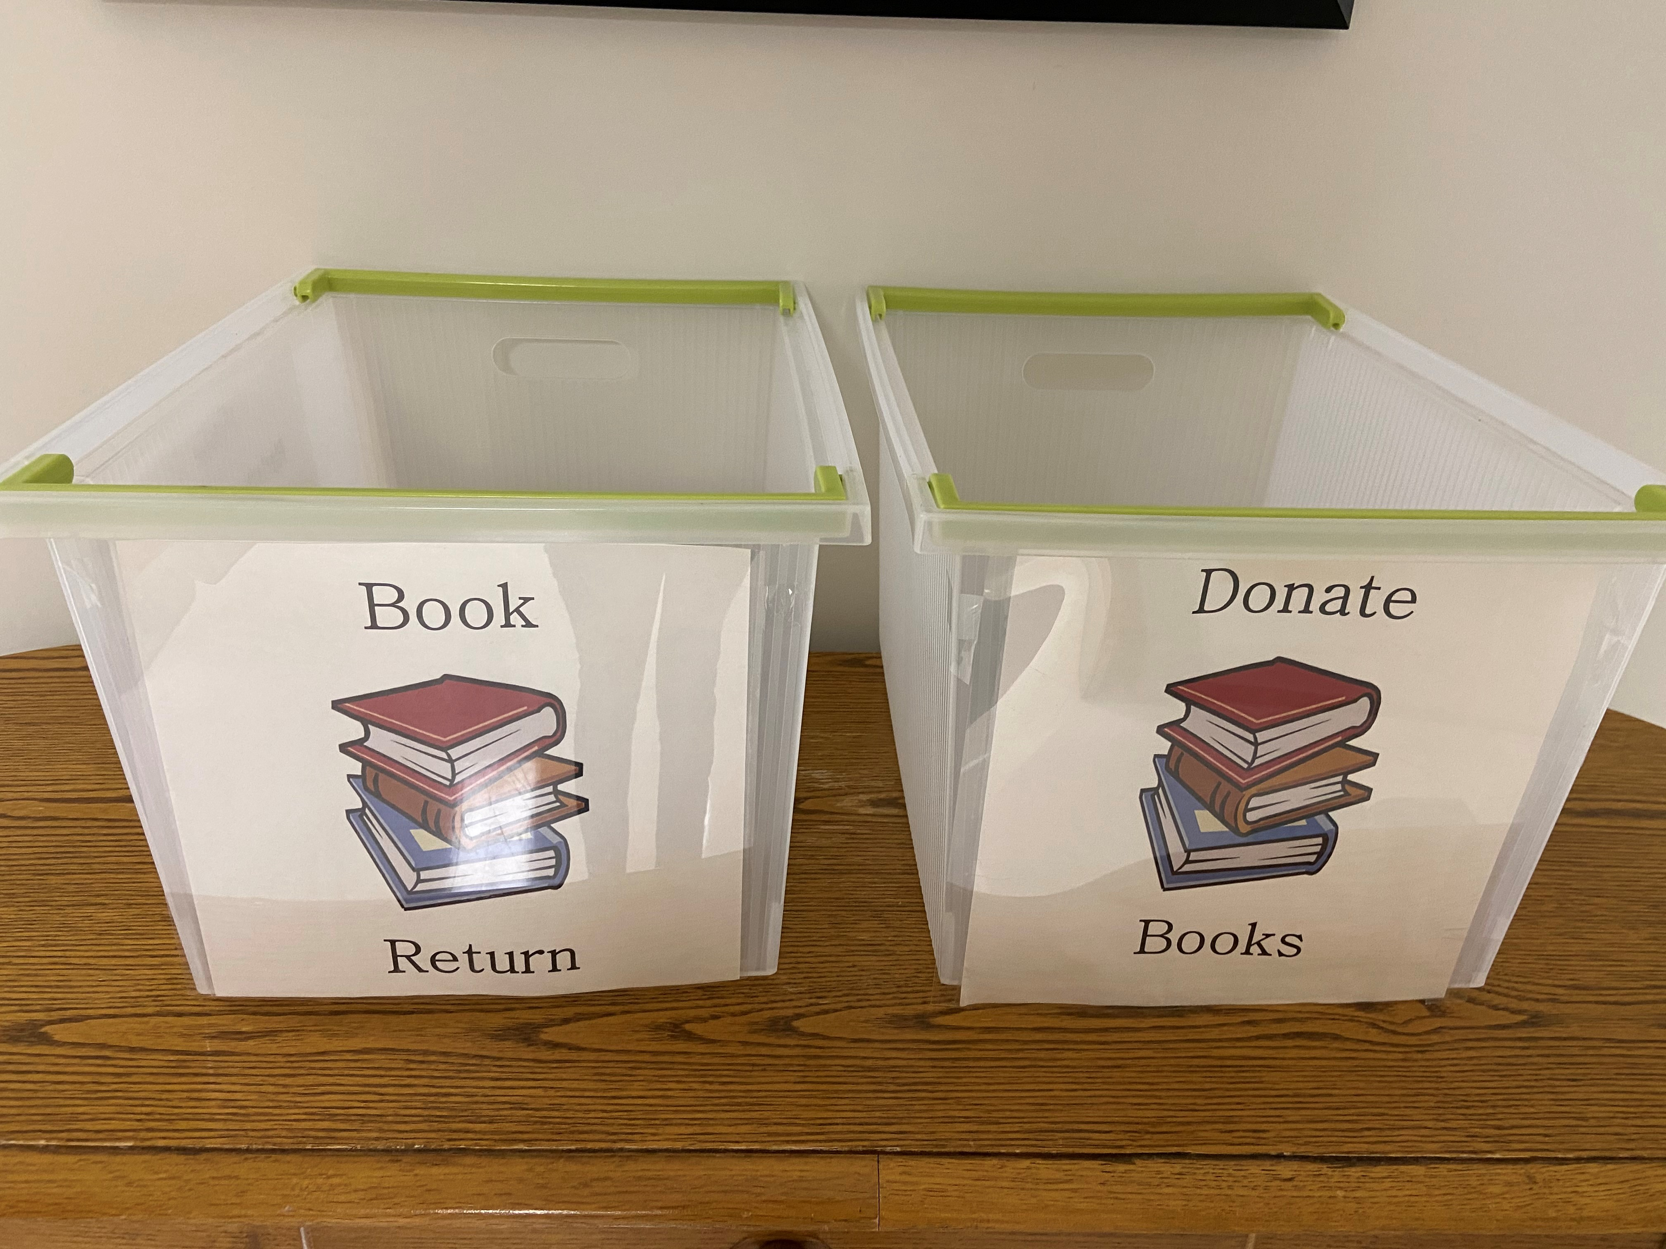  Please return all library books to the designated bins outside of the library!  Book Club  As requested from our residents in our book club, this month’s book is The Wish by Nicholas Sparks.  From the author of The Longest Ride and The Return comes a #1 New York Times bestselling novel about the enduring legacy of first love, and the decisions that haunt us forever.  Limited books available! Please return all book club books to Alex or Anna, do not return to the library! |  | Sweater Weather  Sweater weather is finally here, and there are plenty of holidays to prove it. The International Sweater Vestival, a day that encourages you to rock a sweater vest, falls on December 3, and Ugly Sweater Day follows on December 16. So dig deep into the moth-ball-ridden corners of  your closet and sport that sweater you promised yourself you’d never wear again.  Sweater weather describes that slightly chilly time of year when the weather is perfect for a sweater but not yet cold enough to require a coat. But a sleeveless sweater vest? You can wear one of those anytime! Or does keeping the torso warm and the arms cold mean that such  a garment is useless no matter the season? Utilitarian questions aside, the sweater vest has been shunned for decades as an uncool garment. They were originally donned by rowers in 1882, who wore them to promote sweating and weight loss. Sweater vests hit the mainstream in 1907 when the University of Michigan football team wore them in lieu of sleeved sweaters as the team uniform. Even Presidents Woodrow Wilson and Herbert Hoover sported them, perhaps solidifying their status as uncool. But like so many trends, uncool is becoming cool again.  And besides, the founders of the International Sweater Vestival don’t care whether you wear your sweater vest in earnest or ironically.  When it comes to ugly sweaters, many will point the blame to The Cosby Show’s Cliff Huxtable,  the undisputed king of ugly  ’80s sweaters. But the first ugly sweater party was held at the Commodore Ballroom in Vancouver, British Columbia, in 2002, hosted by Chris Boyd and Jordan Birch. Since then, ugly sweaters worn  for both Christmas and Hanukkah have become a holiday tradition all their own. High fashion  has caught on, with designers selling high-end ugly sweaters for hundreds, even thousands  of dollars. Sleeved or sleeveless, ironic or earnest, ugly or tasteful—no matter what style you choose, sweater weather is here.  December 2022 | Employee Christmas Tree Decorating Contest  Our employees will be competing with each department on the best Christmas Tree decorated! Residents will get to cast their votes starting December 19th until December 22nd at noon. The winner will be announced at the Resident Christmas Party!  Digital Revolution  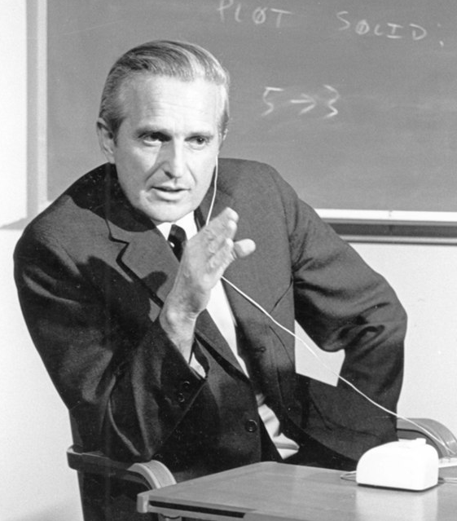  On December 9, 1968, inventor and computer engineer Douglas Engelbart gave what is now known as “The Mother of All Demos” at a computer conference in San Francisco. Engelbart’s  90-minute presentation introduced a number of computing innovations that we take for granted today: windows, hypertext, graphics, word processing, video conferencing, collaborative editing of documents in real-time, and  the computer mouse. Demonstrating all  of these innovations on a single personal computer system in 1968 was groundbreaking. Engelbart’s demo was the result of years of work at his Augmentation Research Center  at Stanford University. He wanted to free computers from mere number crunching  and turn them into tools for communication  and information sharing.

