Activity Calendar |  |  | 9am- Walmart Run (S/U)  9:30am- Sewing Club (SR)  10:15am- Mass (C)  11am- Exercise (GR)  11am- Wreath Making (AR)  1:30pm- Money Bingo (GR)  1:30pm- Pinecone Centerpieces (AR)  3pm- Tea Party (AR)  3pm- Book Club (L)  6:30pm- Card Games (L) | 9am- Standing Exercise (GR)  10:15am- Mass (C)  11am- Nail Salon (AR)  1:30pm- Paint by #’s (AR)  3pm- Christmas Cards (AR)  6:30pm- Genealogy (L) | 9am- Scenic Drive (S/U)  10:15am- Mass (C)  11am- Popsicle Log Cabins (AR)  11am- Exercise (GR)  1pm- Walking Group (TH)  2pm- Regular Bingo (GR)  3pm- Happy Hour (GR) | 8am- Uno (AR)  9am- Pool (GR)  10am- Crafts (AR)  11am- Exercise (GR)  National Cookie Day
10:30am- Rosary (C)  11am- Mass (C)  12pm- Chiefs VS. Broncos | 9am- Kings in the Corner (AR)  9am- Pool (GR)  10:15am- Mass (C)  11am- Exercise (GR)  11am- Ornament Making (AR)  1:30pm- Money Bingo (GR)  1:30pm- Favorite Family Recipe (AR)  3pm- Christmas Movie Monday (AR) | 8am- Yahtzee (AR)  9am- Left, Right, Center (AR)  9am- Standing Exercise (GR)  10:15am- Mass (C)  11am- Nail Salon (AR)  1:30pm- Paint by #’s (AR)  1:30pm- Blackjack (AR)  2pm- Protestant Service (C)  3pm- Crochet Club (SR) | 9am- Walmart Run (S/U)  9:30am- Sewing Club (SR)  10:15am- Mass (C)  11am- Exercise (GR)  11am- Vote on Lunch Outing (S/U)  1:30pm- Money Bingo (GR)  3pm-Chrismas Centerpieces (AR)  6:30pm- Card Games (L) | 9am- Tassel Makings (AR)  9am- Standing Exercise (GR)  10:15am- Mass (C)  11am- Nail Salon (AR)  1:30pm- Paint by #’s (AR)  3pm- Ceramic Painting (AR)  6:30pm- Genealogy (L) | 9am- Scenic Drive (S/U)  10:15am- Mass (C)  11am- Mason Jar Gifts (AR)  11am- Exercise (GR)  1pm- Walking Group (TH)  2pm- Regular Bingo (GR)  3pm- Happy Hour (GR) | 8am- Uno (AR)  9am- Pool (GR)  10am- Crafts (AR)  11am- Exercise (GR)  Christmas Jumper Day
10:30am- Rosary (C)  11am- Mass (C)  12pm- Chiefs VS. Raiders | 9am- Uno (AR)  9am- Pool (GR)  10:15am- Mass (C)  11am- Exercise (GR)  11am- Christmas Gnomes (AR)  1:30pm- Money Bingo (GR)  1:30pm- Popsicle Angels (AR)  3pm- Christmas Movie Monday (AR) | 8am- Monopoly (AR)  9am- Door Tags (AR)  9am- Standing Exercise (GR)  10:15am- Mass (C)  11am- Nail Salon (AR)  1:30pm- Paint by #’s (AR)  1:30pm- Mini Winter Hats (AR)  2pm- Protestant Service (C)  3pm- Popsicle Santa Claus  3pm- Apartment Meeting (TH) | 9am- Walmart Run (S/U)  9:30am- Sewing Club (SR)  10:15am- Mass (C)  10:30am- Auxiliary of Our Lady  11am- Exercise (GR)  11am- Cookie Decorating (GR)  12:15pm- Christmas Caroling (DH)  1:30pm- Money Bingo (GR)  3pm- Book Club (L)  3pm- RCF Meeting (GR)  6:30pm- Card Games (L) | 9am- Mini Stocking Hats (AR)  9am- Standing Exercise (GR)  10:15am- Mass (C)  11am- Nail Salon (GR)  1:30pm- Paint by Numbers (AR)  3pm- Ceramic Painting (AR)  6:30pm- Genealogy (L)  PODIATRIST- APT | 9am- Scenic Drive (S/U)  10:15am- Mass (C)  11am-Snowflakes Corks (AR)  11am- Exercise (GR)  1pm- Walking Group (TH)  2pm- Regular Bingo (GR)  3pm- Happy Hour (GR)  PODIATRIST- RCF | 8am- Uno (AR)  9am- Pool (GR)  10am- Crafts (AR)  11am- Exercise (GR)  National Wreaths Across America Day
10:30am- Rosary (C)  11am- Mass (C)  Spirit Week | 9am- Kings in the Corner (AR)  9am- Pool (GR)  10:15am- Mass (C)  11am- Exercise (GR)  11am- Christmas Tree Crafts (AR)  1:30pm- Money Bingo (GR)  1:30pm- Popsicle Angels (AR)  3pm- Christmas Movie Monday (AR)  Pajama Day | 8am- Yahtzee (AR)  9am- Left, Right, Center (AR)  9am- Standing Exercise (GR)  10:15am- Mass (C)  11am- Nail Salon (AR)  1:30pm- Let’s Wrap Presents (AR)  1:30pm- Paint by #’s (AR)  2pm- Protestant Service (C)  3pm- Crochet Club (SR)  Elf Day | 8am- Walmart Run (S/U)  9:30-11:30am- Sewing Club (CR)  10:15am- Mass (C)  11am- Exercise (GR)  11am- Vote on Lunch Outing (S/U)  2-3:30pm- Christmas Party (TH)  6:30pm- Card Games (L)  Ugly Sweater Day | 9am- Standing Class (GR)  10:15am- Mass (C)  11am- Toilet Paper Snowman (AR)  1:30pm- Ceramic Painting (AR)  3pm- Popsicle Snowman (AR)  6:30pm- Genealogy (L)  Christmas Hat Day | 8am- UNO (AR)  9am- Button Wreath (AR)  10am- Exercise (GR)  10:15am- Mass (C)  11am- Happy Hour (GR)  Red Friday | 
10:30am- Rosary (C)  11am- Mass (C) | 9am- Pool (GR)  10:15am- Mass (C)  11am- Exercise (GR)  1:30pm- Money Bingo (GR)  3pm- Movie Monday (AR) | 8am- Monopoly (AR)  9am- Door Knockers (AR)  9am- Standing Exercise (GR)  10:15am- Mass (C)  11am- Nail Salon (AR)  1:30pm- Blackjack (AR)  1:30pm- Paint by #’s (AR)  2pm- Protestant Service (C)  3pm-New Year’s Eve Hats (AR) | 9am- Walmart Run (S/U)  10:15am- Mass (C)  11am- Exercise (GR)  11am- New Year Wishes (AR)  1:30pm- Money Bingo (GR)  3pm- Book Club (L)  6:30pm- Card Games (L) | 9am- Standing Class (GR)  10:15am- Mass (C)  11am- Nail Salon (AR)  2-3:30pm- New Year’s Eve Party (TH)  6:30pm- Genealogy (L) | 10:15am- Mass (C)  11am- Exercise (GR)  1pm- Walking Group (TH)  2pm- Regular Bingo (GR)  3pm- Happy Hour (GR) | CODES:  GR- Game Room  C- Chapel  AR- Activity Room  L- Library  TH- Tighe Hall  S/U- Sign Up  DH- Dining Hall
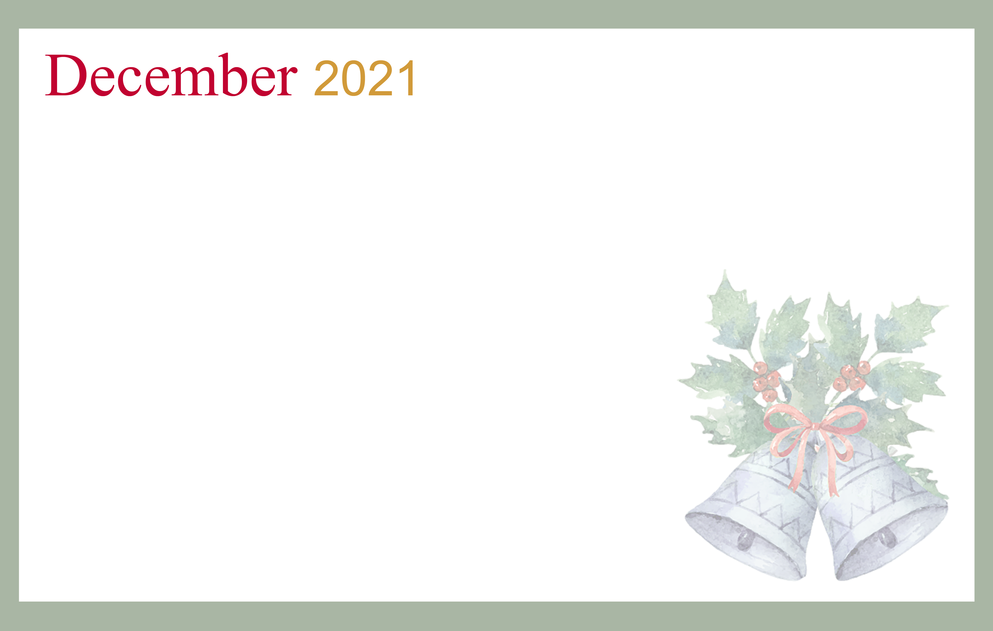
Our Lady of Mercy Country Home | Care with Dignity | 2115 Maturana Drive Liberty, MO 64068 | 816-781-5711
Sunday | Monday | Tuesday | Wednesday | Thursday | Friday | Saturday
 |  |  | 1 | 2 | 3 | 4
5 | 6 | 7 | 8 | 9 | 10 | 11
12 | 13 | 14 | 15 | 16 | 17 | 18
19 | 20 | 21  Winter Begins | 22 | 23 | 24 | 25  Christmas
26  Kwanzaa Begins | 27 | 28 | 29 | 30 | 31  New Year’s Eve

